**Empowering Sustainability: EcoElevate's E-Commerce Proposal**

**Course Code**

**CRN**

**Faculty Name**

**Date**

**Group Members**

**Table of Contents**

PART 1-E-COMMERCE PROPOSAL 3

Introduction 3

Industry Analysis using 5 Competitive Forces Model 3

Analyze the Existing Market Competitors 3

Evakind 3

The Green Ecostore Business description 4

EcoElevate Business Model Products 5

Revenue Strategy and Distribution Plan for EcoElevate 5

Distribution 5

Industry analysis using Porter's 5 Forces model 6

Strategies Regarding Customer Awareness 6

Competitive Advantage 6

Appendix 7

Website Link 7

Screenshot 7

Logbook 7

References 8

# PART 1-E-COMMERCE PROPOSAL

# Introduction

EcoElevate is a groundbreaking organization committed to revolutionizing the manner in which we interact with the environment. With a steadfast dedication to sustainability and eco-conscious practices, EcoElevate plans to lead the charge in giving innovative, excellent eco-friendly products to consumers worldwide. Our main goal isn't just to offer environmentally responsible alternatives yet in addition to inspire and empower people to make cognizant choices that positively influence the planet.

This proposal delves into EcoElevet's strategic framework, illustrating the vision for the e-commerce stage and detailing our convention in order to deal with designating a flourishing business in the domain of eco-friendly products. Starting from the business model to remuneration streams, distribution strategies, as well as competitive benefits, it spread out a thoroughgoing intent to ensure the sustainability of EcoElevet in the competitive e-commerce landscape. With the help of detailed industry analysis utilising Porter's Five Forces model as well as a perceptive emphasis on customer outreach along engagement, it is expected to situate Evakind as a leading destination for environmentally cognizant consumers.

# Industry Analysis using 5 Competitive Forces Model

## Analyze the Existing Market Competitors

### Evakind

#### Evakind Business description

Evakind is an e-commerce-based online platform that offers eco-friendly products. Founded by Sladjana Franovic, this green Dubai startup is committed to revolutionizing the method in which people shop by sustaining small, independent nearby along with international brands that prioritize ethical, sustainable, as well as environment-friendly values (Evakind, 2021).

#### Company’s Mission

Evakind's mission is clear: to supply consumers with access to a curated preference for eco-friendly products while sustaining businesses dedicated to ethical production methods.This green Dubai startup is on a mission to champion small, independent local and international brands that hold ethical, sustainable, and environment-friendly values.

By empowering customers to make conscious choices they are focusing on environmental sustainability (Evakind, 2021). They offer a wide range of eco-friendly green products which are mainly homeware, cleaning products, personal care items, and beauty products.

#### Company Analysis

|  |  |
| --- | --- |
| ***Strengths*** | ***Weakness*** |
| * Online shopping platform. * Offers a diverse range of eco-friendly products * Stands out by championing small, independent local and international brands that align with sustainable and ethical values * Offers Plastic-Free and High-Quality products * Since the company is owned by Casinetto, it has a strong supply chain network. * The company can import eco-friendly products from all over the world and sell them to its home regions. | * Poor online presence resulted in Limited Brand Recognition * High product costs * Underperforming Initiatives * Poor Marketing strategies |

### The Green Ecostore Business description

The Green Ecostore is one of the growing Dubai-based online companies, launched in 2009 the aim of the company is to reduce waste, conserve resources, and maintain environmental sustainability by offering a wide range of eco-friendly products (The Green Ecostore, 2021).

#### Company’s Mission

Their mission is to create a positive impact on the environment and promote a greener lifestyle. They offer a diverse range of sustainable and ethical products such as reusable coffee cups to produce bags, healing crystal bracelets made from natural stones, plantable seed paper, and Eco-Friendly Cleaning products (The Green Ecostore, 2021).

#### Company Analysis

|  |  |
| --- | --- |
| ***Strengths*** | ***Weakness*** |
| The company has 14 years of experience.  They have a strong customer base.  Their products are used by individuals and companies across the UAE.  Partnerships with Eco Manufacturers like the best eco manufacturers globally | Faced challenges due to middlemen intervention, affecting costs and efficiency.  Facing intense market competition in an eco-friendly market.  Limited Marketing Reach  Supply Chain Vulnerabilities  Limited Product Range of around 200 |

## EcoElevate Business Model Products

EcoElevate operates with a Business-to-consumer (B2C) model primarily. The company will offer a wide range of products online. The products include Organic skincare products, Sustainable Fashion Accessories, Eco-Friendly Beauty Products, Zero-Waste Lifestyle Products and Ethical Fashion Clothing. Although major cities like Dubai boast robust internet infrastructure and diverse consumer markets, for the company it will be essential to maintain a balance between operational expenses and profit (Tahir & Raza, 2020). Therefore for a startup, it will be challenging to maintain that balance thus the company will strategically choose a location that optimizes market reach, operational efficiency, and alignment with its values.

## Revenue Strategy and Distribution Plan for EcoElevate

EcoElevate's essential revenue source revolves around item sales facilitated through its e-commerce platform. As a benefit-driven entity, the clear nature of revenue generation from item sales lines up with EcoElevate's business model. The platform specializes in offering a curated selection of eco-friendly products sourced from little, independent brands, catering to environmentally cognizant consumers. Moreover, EcoElevate seeks to diversify its revenue streams through strategic partnerships with brands, enabling featured item placements, sponsored content, and affiliate marketing initiatives.

## Distribution

In terms of distribution, EcoElevate is strategically positioned to optimize its coordinated factors operations through partnerships with reputable planned operations companies and couriers. These alliances will assume an urgent part in ensuring the efficient fulfilment and delivery of orders to customers. By implementing a vigorous distribution strategy, EcoElevate plans to provide multiple transportation choices, including eco-friendly bundling choices, thereby enhancing the sustainability of its operations while delivering a seamless shopping experience for customers. Through these concerted efforts, EcoElevate endeavours to maximize revenue opportunities while maintaining its commitment to advancing sustainability and ethical consumption.

## Industry analysis using Porter's 5 Forces model

|  |  |
| --- | --- |
| **Forces** | **Analysis** |
| Threat of New Entrants | ***Low to moderate***. While the e-commerce sector has minimum entry barriers, developing a brand image as well as establishing supplier connections pose a risk. |
| Bargaining power of Suppliers | ***Moderate***. Suppliers of eco-friendly products have some advantages because of the uniqueness of the product, but the firm can address this by sourcing from various suppliers. |
| Bargaining power of the buyer | ***Moderate to high***. Buyers have access to different eco-friendly products. This gives them the power to negotiate prices. The firm can address this via loyalty to the brand as well as unique offerings. |
| Threat of Substitutes | ***Low to moderate***. While substitutes exist, The firm's concentration on sustainability, as well as curated selection, differentiates it, minimizing the threat of customers switching. |
| Competitive Rivalry | ***High***. The e-commerce sector is highly competitive, with various players. The firm's niche concentration on eco-friendly products offers a unique positioning advantage. |

## Strategies Regarding Customer Awareness

A wide range of marketing strategies will be used by EcoElevet to ensure that customers are aware of them. This involves advertising on social media, influencer connections, SEO, email marketing, etc. These strategies are used as they make use of a wide range of channels to connect with a wide range of individuals, which eventually increase visibility as well as engagement of the firm.

## Competitive Advantage

EcoElevet's competitive advantage lies in differentiation via its concentration on sustainability as well as carefully selected offerings of the product. The firm sets itself apart from traditional e-commerce platforms by offering only products which are eco-friendly, thus benefiting from the growing demand of consumers for environmentally conscious consumption. Customers who like to make ethical purchases are attracted to the firm's mission of sustainability, which develops brand loyalty as well as confidence. Additionally, EcoElevet's curated selection assures proper quality as well as relevance, offering customers guarantee and comfort. By utilizing the differentiation strategy, the firm distinguishes itself from its competitors.

# Appendix

## Website Link

EcoElevet can be accessible here <https://ecoelevet.godaddysites.com/>.

## Screenshot

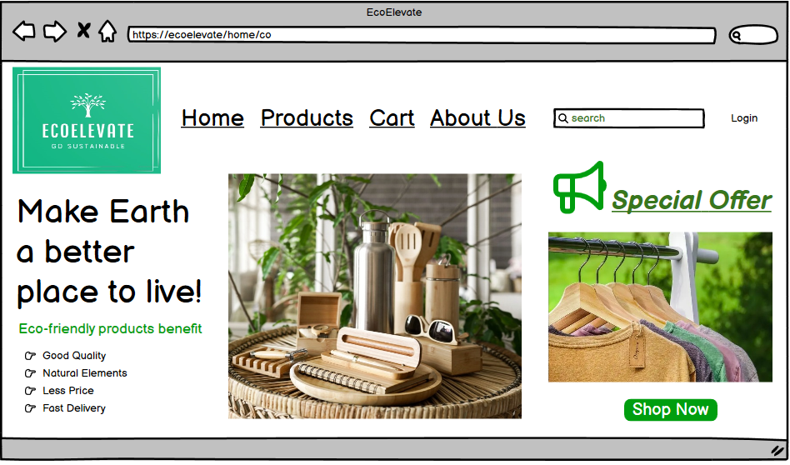

Fig: Home Page Desktop View

Source: Self

## Logbook

|  |  |  |
| --- | --- | --- |
| **Group Member** | **Tasks** | **Completion Date** |
| Team Members’ names Please | Conducted market research on eco-friendly item trends and consumer preferences. | 2024-02-15 |
|  | Created the business model material for EcoElevate, showing revenue streams and cost structure | 2024-02-18 |
|  | Designed the user interface and user experience (UI/UX) for the e-commerce platform. | 2024-02-20 |
|  | Developed the website backend, including database management and payment integration | 2024-02-23 |
|  | Executed marketing strategies, including online entertainment crusades and influencer partnerships | 2024-02-25 |
|  | Compiled the business investigation using Porter's Five Forces model, identifying competitors and market elements | 2024-02-28 |

# References

EcoElevet <https://ecoelevet.godaddysites.com/>

Evakind. (2021, October 25). Go-Lokal. <https://go-lokal.com/evakind/>

Homepage - The Green Ecostore A Dubai Based Online Store For Eco-Friendly & Sustainable Products. (2021, December 8). <https://thegreenecostore.com/>

Khaleeli, M., & Jawabri, A. (2021). The effect of environmental awareness on consumers’ attitudes and consumers’ intention to purchase environmentally friendly products: Evidence from United Arab Emirates. *Management Science Letters, 11(2), 555-560.*

Okasha, A. A. (2020). Entrepreneurship in the United Arab Emirates. *In Entrepreneurial innovation and economic development in Dubai and comparisons to its sister cities (pp. 158-182). IGI Global.*

Tahir, R., & Raza, A. (2020). Motivations of the female entrepreneurs to start online businesses in the United Arab Emirates. *International Journal of Innovation and Technology Management, 17(07), 2050047.*